**CS2040S: Data Structures and Algorithms**

Discussion Group Problems for Week 4

*For: February 3–February 7*

# Problem 1. Time Complexity Analysis

Analyse the following code snippets and find the best asymptotic bound for the time complexity of the following functions with respect to *n*.

1. public int niceFunction(int n) {

for (int i = 0; i < n; i++) {

System.out.println("I am nice!");

}

return 42;

}

Ans: T(n) = O(n)

1. public int meanFunction(int n) {

if (n == 0) return 0;

return 2 * meanFunction(n / 2)+ niceFunction(n);

}

Ans: T(n) = T( $\frac{n}{2}$) + O(n)

= T( $\frac{n}{2^{2}}$) + O( $\frac{n}{2}$) + O(n)

= T( $\frac{n}{2^{3}}$) + O( $\frac{n}{2^{2}}$) + O( $\frac{n}{2}$) + O(n)

= T(1) + (O(n) + O( $\frac{n}{2}$) + O( $\frac{n}{2^{2}}$) + O( $\frac{n}{2^{3}}$) + …)

= O(n)

1. public int strangerFunction(int n) {

for (int i = 0; i < n; i++) {

for (int j = 0; j < i; j++) {

System.out.println("Execute order?");

}

}

return 66;

}

Ans: T(n) = 0 + 1 + 2 + 3 + … + (n – 1)

= O( $\frac{n (n-1)}{2}$)

= O($n^{2}$)

1. public int suspiciousFunction(int n) {

if (n == 0) return 2040;

int a = suspiciousFunction(n / 2);

int b = suspiciousFunction(n / 2);

return a + b + niceFunction(n);

}

Ans: T(n) = 2 T( $\frac{n}{2}$) + O(n)

= O(n) * O($\log{n}$)

= O(n $\log{n}$)

1. public int badFunction(int n) {

if (n <= 0) return 2040;

if (n == 1) return 2040;

return badFunction(n - 1) + badFunction(n - 2) + 0;

}

Note: The *n*th Fibonacci number can be expressed as 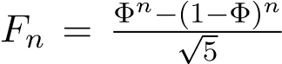, where Φ = 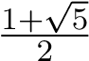.

E.g. *F*0 = 0, *F*1 = 1.

Ans: T(n) = T(n – 1) + T(n – 2) + O(1)

1. public int metalGearFunction(int n) {

for (int i = 0; i < n; i++) {

for (int j = 1; j < i; j *= 2) {

System.out.println("!");

}

}

return 0;

}

Ans: T(n) = log(1) + log(2) + … + log(n)

= log($1×2×…×n)$

= log(n!)

= O(n $\log{n}$)

1. public String simpleFunction(int n) {

String s = "";

for (int i = 0; i < n; i++) {

s += "?";

}

return s;

}

Ans: T(n) = O($n^{2}$)

# Problem 2. Sorting Review

1. How would you implement insertion sort recursively? Analyse the time complexity by formulating a recurrence relation.

Recursively sort the array from index 0 to (n – 1). Then, insert the last element into the sorted subarray. The recurrence relation will be T(n) = T(n – 1) + O(n). Solving it results in time complexity O($n^{2}$).

1. Consider an array of pairs (*a,b*). Your goal is to sort them by *a* in ascending order. If there are any ties, we break them by sorting *b* in ascending order. For example, [(2, 1), (1, 4), (1, 3)] should be sorted into [(1, 3), (1, 4), (2, 1)].

You are given 2 sorting functions, which are a MergeSort and a SelectionSort. You can use each sort at most once. How would you sort the pairs? Assume you can only sort by one field at a time.

You should use the SelectionSort to sort the pairs by *b* first, and then use MergeSort to sort the pairs by *a*. This is because, MergeSort is stable and would not affect the ordering of *b* (which is already sorted) when *a* has the same value.

1. We have learned how to implement MergeSort recursively. How would you implement MergeSort iteratively? Analyse the time and space complexity.

# Problem 3. Queues and Stacks Review

Consider the Stack and Queue Abstract Data Types (ADTs). Just a quick explanation, a Stack is a “LIFO” (Last In First Out) collection of elements that supports the following operations in *O*(1) time:

* **push**: Adds an element to the stack
* **pop**: Removes the **last** element that was added to the stack
* **peek**: Returns the last element added to the stack (without removing it)

A Queue is a “FIFO” (First In First Out) collection of elements that supports these operations in *O*(1) time:

* **enqueue**: Adds an element to the queue front
* **dequeue**: Removes the **first** element that was added to the queue
* **peek**: Returns the next item to be dequeued (without removing it)

1. How would you implement a stack and queue with a fixed-size array in Java? (Assume that the number of items in the collections never exceed the array’s capacity.)

**Stack:**

Create an int field called lastElem, which stores the current index of the last element in the array. When a push operation is done, the lastElem field will be incremented by 1. When a pop operation is done, it will remove the last element in the array and decrement the value of lastElem by 1. Lastly, when a peek operation is done, the last element of the array will be returned but the value of lastElem remains unchanged.

**Queue:**

Create an int field front, that stores the index of the first element of the queue, and an int field back, that stores the index of the last element of the queue. Both front and back values are initialised to 0. When an enqueue operation is done, set arr[back] to the element to be inserted, and increment the value of back by 1. When a dequeue operation is done, simply return arr[front] and increment the value of front by 1. When a peek operation is done, simply return arr[front] without modifying the value of front. In order to prevent an array index out of bounds error, we can edit the enqueue and dequeue operations to increment the respective values of front and back and proceed to do a mod operation with the length of the array (i.e. (front + 1) % arr.length). This would proceed to utilise the empty spaces at the front of the array.

1. A Deque (double-ended queue) is an extension of a queue, which allows enqueueing and dequeueing from both ends of the queue. So the operations it would suppport are *enqueue front*, *dequeue front*, *enqueue back*, *dequeue back*. How can we implement a Deque with a fixed-size array in Java? (Again, assume that the number of items in the collections never exceed the array’s capacity.)
2. What sorts of error handling would we need, and how can we best handle these situations?

We would need to have error handling to check for when the array is full when performing enqueue/push operations. If the array is full and no more elements can be added, an error would need to be thrown. On the other hand, for dequeue/pop operations, we would need to check if the array is empty. If the array is empty and there are no elements to be removed from the array, an error would need to be thrown.

1. A sequence of parentheses is said to be balanced as long as every opening parenthesis “(” is closed by a closing parenthesis “)”. So for example, the strings “()()” and “(())” are balanced but the strings “)(())(” and “((” are not. Using a stack, determine whether a string of parentheses are balanced.
2. A sequence of opening and closing parentheses of three different types {}, (), and [] is given. We will define a hyperbalanced parenthesis sequence in a recursive way. For the recursion base, we say that empty parentheses sequence is a hyperbalanced one. Next, if “X” and “Y” are hyperbalanced sequences, then any of the sequences “{X}”, “[X]”, “(X)”, and “XY” is hyperbalanced. For example, sequences “{}([{}])”, “{}”, “(((())))” are hyperbalanced, but sequences “{(})”, “]”, “({}” are not. Determine whether a given sequence of parentheses is hyperbalanced.

# Problem 4. Mountain stack

Adventure flows in your veins, and today, you embark on your journey through the mountains! The range consists of *n* hills, aligned linearly and numbered from 0 to *n* − 1. Each hill, indexed at *i*, stands at a height of *a*[*i*] meters and spans a length of 1 kilometer. As you plan your journey, you’re keen to understand how far you can see to your left (you choose not to look right due to the prevailing winds in the mountains). When you stand atop hill *i* and look leftward, you’ll see a point *j* kilometers away if and only if all hills from *i*−*j* to *i* are no taller than *a*[*i*] meters. For each hill *i*, determine the maximum distance you can see from it. If there are no hills *j < i* taller than *i* then the answer for *i* is ”infinity”. Your goal is to solve this problem as effectively as possible.

(Hint: try using a stack to achieve *O*(*n*) time complexity).

Example:

[1, 0, 1, 2, 3, 1, 2, 3, 0]

The array above can be represented with the diagram below.

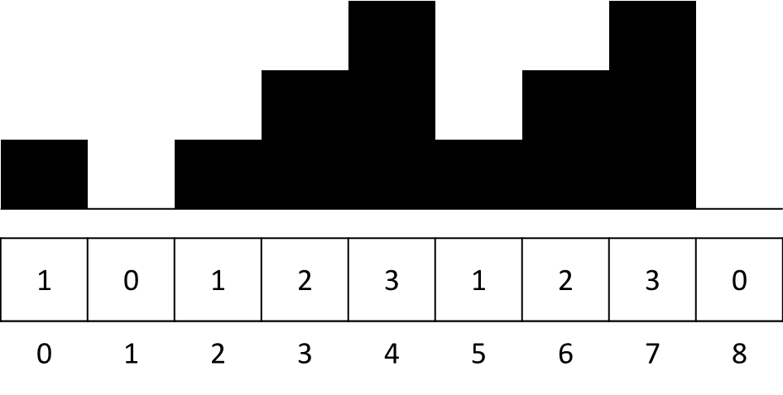

For hills numbered 0, 2, 3, 4, and 7, there are no taller hills to their left; therefore, the answer for them is ”infinity”. For the hill with index 1, it is impossible to see even 1 km to the left, as the hill at index 0 is taller, and thus the answer is 0. The same applies to the hill numbered 5, as *a*[4] *> a*[5]. However, when standing on top of hill 6, one can observe 1 km to the left, since *a*[5] ≤ *a*[6] and does not limit the sight. But the view is limited beyond that, as *a*[4] *> a*[6].

# Problem 5. Sorting with Queues

*(Optional)* Sort a queue using another queue with *O*(1) additional space.